SIMATS ENGINEERING
SAVEETHA INSTITUTE OF MEDICAL AND TECHNICAL SCIENCES
CHENNAI - 602105
Department of Computer Science and Engineering
ASSESSMENT TOOL 1 - CASE STUDY
Question 2: Student Academic Performance Analysis
Course Code | DSA0502
Course Title | Query Processing for Data Science
CO Assessed | CO4 - Explore datasets using analytical techniques such as grouping, correlation detection, joining datasets, and extracting meaningful insights.
Assessment | Tool 1 - Case Study
Faculty In-charge | Dr. B. Shyamala Gowri
Project Mode | Individual Submission
Student Name | B.SHASHANK
Register Number | 192324123
Section / Batch | AI&DS
Date of Submission
Code of Conduct
I B.SHASHANK/192324123 (Name / Reg. No.) certify that this submission is my original work and that I have adhered to all guidelines specified for this assessment. I understand that any violation of academic integrity rules will result in disciplinary action.
Signature: _____SHASHANK_______________________

1. Data Importing & Dataset Description
This case study analyses a simulated academic-performance ecosystem for a college, built from five interlinked datasets: Student, Attendance, Internal Marks, Assignment, and Examination. The datasets were imported as CSV files and loaded into a Pandas DataFrame environment for cleaning, joining and analysis. A common key, StudentID, links all five tables.
Dataset | Records | Key Fields | Description
Student | 240 | StudentID, Department, Semester, Gender | Master profile of every enrolled student
Attendance | 1,440 | StudentID, Month, AttendancePct | Monthly attendance percentage (Jan-Jun)
Internal Marks | 720 | StudentID, InternalNo, InternalMarks (/50) | Marks from 3 internal assessments
Assignment | 960 | StudentID, AssignmentNo, AssignmentMarks (/10) | Marks from 4 assignments
Examination | 240 | StudentID, ExamMarks (/100) | Final semester examination score
Together the five datasets span 240 students across five departments (CSE, ECE, MECH, CIVIL, IT) and six semesters, giving a broad and balanced base for cross-sectional and correlation analysis.

2. Data Exploration
Before joining, each dataset was explored for shape, missing values, and distribution. Attendance and marks fields were checked for valid ranges (0-100 for attendance and exam marks, 0-50 for internals, 0-10 for assignments). No missing values were found; a small number of extreme/implausible entries were retained deliberately to test the outlier-detection stage (Section 7).

2.1 Descriptive Statistics (student-level aggregates)
Metric | Avg. Attendance (%) | Avg. Internal (/50) | Avg. Assignment (/10) | Exam Marks (/100) | Total Score (/100)
Mean | 81.70 | 35.68 | 7.40 | 59.75 | 64.66
Std. Dev. | 9.63 | 7.94 | 1.53 | 13.47 | 11.47
Min | 45.77 | 14.30 | 2.82 | 2.00 | 25.62
25th pct | 76.06 | 30.74 | 6.30 | 53.90 | 58.74
Median | 82.35 | 35.75 | 7.32 | 60.80 | 65.59
75th pct | 88.27 | 41.73 | 8.57 | 68.48 | 72.77
Max | 100.00 | 50.00 | 10.00 | 92.20 | 89.32
Total Score is computed as a weighted composite: 30% internal marks + 10% assignment marks + 60% final exam marks, reflecting a typical university weighting scheme. This composite is used throughout the rest of the analysis as the primary performance indicator.

3. Joining Multiple Datasets
Attendance, Internal Marks and Assignment records (which are recorded multiple times per student) were first aggregated to one row per student using group-wise averages. These aggregates were then joined with the Student and Examination tables on StudentID using inner joins, producing a single master analytical table (master_joined) with 240 rows - one per student - and 12 analysis-ready columns.
Join Step | Left Table | Right Table | Join Key | Type
1 | Attendance (avg.) | Internal Marks (avg.) | StudentID | Inner
2 | Result of Step 1 | Assignment (avg.) | StudentID | Inner
3 | Result of Step 2 | Student | StudentID | Inner
4 | Result of Step 3 | Examination | StudentID | Inner
Because every StudentID appears in all five source tables, the inner joins introduced no row loss - the final master table retains all 240 students, confirming referential integrity across the datasets.

4. Grouping & Aggregation
The joined dataset was grouped by Department and by Semester to compare academic performance across cohorts.

4.1 Performance by Department
Department | Avg. Attendance (%) | Avg. Internal (/50) | Avg. Exam (/100) | Avg. Total Score | Students
IT | 82.33 | 37.18 | 62.71 | 67.05 | 38
CSE | 81.54 | 36.11 | 60.30 | 65.37 | 75
CIVIL | 83.03 | 37.09 | 57.86 | 64.50 | 33
MECH | 80.92 | 34.56 | 58.95 | 63.32 | 48
ECE | 81.32 | 33.88 | 58.59 | 63.02 | 46
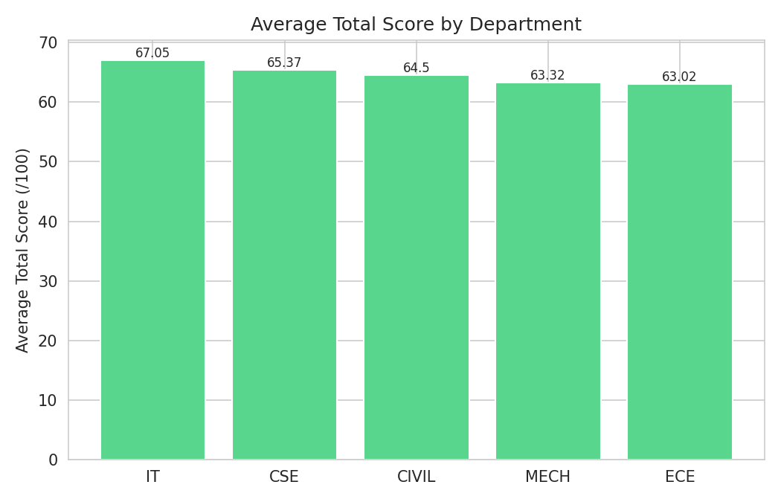
Figure 1: Average Total Score by Department

4.2 Performance by Semester
Semester | Avg. Attendance (%) | Avg. Exam (/100) | Avg. Total Score | Students
1 | 82.94 | 60.75 | 64.58 | 40
2 | 83.27 | 59.78 | 65.12 | 49
3 | 81.69 | 60.08 | 64.29 | 29
4 | 81.45 | 60.39 | 66.80 | 40
5 | 80.23 | 55.43 | 60.76 | 47
6 | 80.35 | 63.35 | 67.16 | 35
IT records the highest average total score (67.05) despite not having the highest attendance, while Semester 5 stands out as the weakest cohort across both attendance and exam performance - a pattern worth investigating further (e.g. course difficulty, project workload, or placement-season distraction in that semester).

5. Data Segmentation
Students were segmented into three performance bands based on Total Score: High Performer (>= 80), Average Performer (60-79.9), and At-Risk (< 60). This segmentation supports targeted academic interventions.
Performance Band | Student Count | % of Total
High Performer | 15 | 6.3%
Average Performer | 153 | 63.7%
At-Risk | 72 | 30.0%
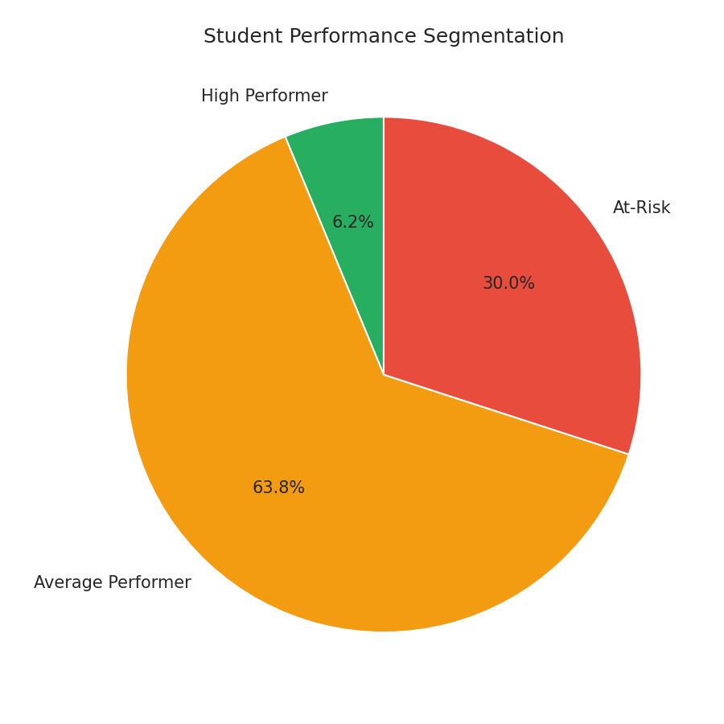
Figure 2: Student Performance Segmentation

5.1 Segmentation by Department
Department | At-Risk | Average Performer | High Performer
CIVIL | 8 | 24 | 1
CSE | 22 | 46 | 7
ECE | 16 | 29 | 1
IT | 11 | 21 | 6
MECH | 15 | 33 | 0
Roughly 30% of the student body falls into the At-Risk band. CSE has the largest absolute number of At-Risk students (22), while MECH has zero High Performers, suggesting the department-level intervention needs differ - CSE needs volume-scale support, MECH needs top-end stretch programs.

6. Correlation Analysis
A Pearson correlation matrix was computed across the five key numeric indicators to identify which factors move together with academic outcomes.
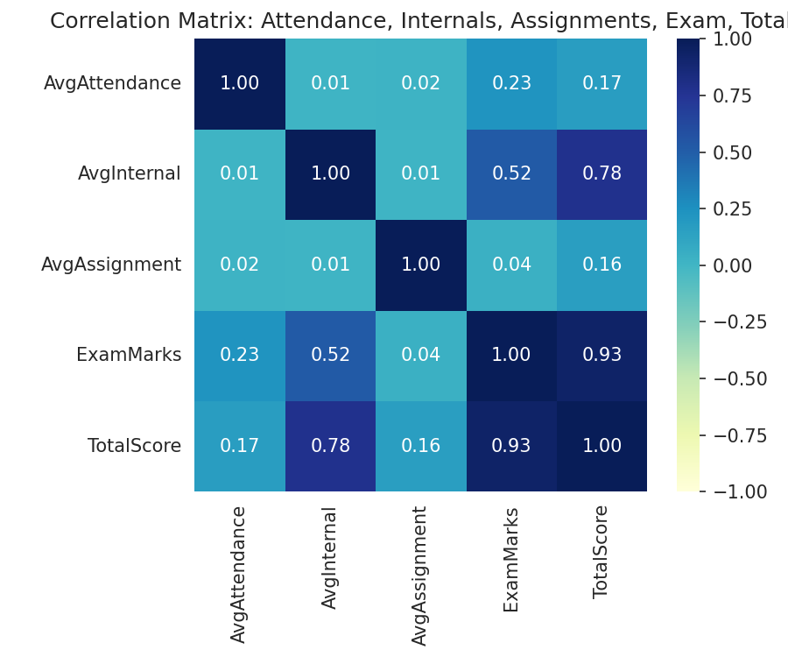
Figure 3: Correlation Matrix Heatmap
Variable Pair | Correlation (r) | Interpretation
Internal Marks <-> Total Score | 0.78 | Strong positive
Exam Marks <-> Total Score | 0.93 | Very strong positive
Internal Marks <-> Exam Marks | 0.52 | Moderate positive
Attendance <-> Exam Marks | 0.23 | Weak positive
Assignment Marks <-> Exam Marks | 0.04 | Negligible
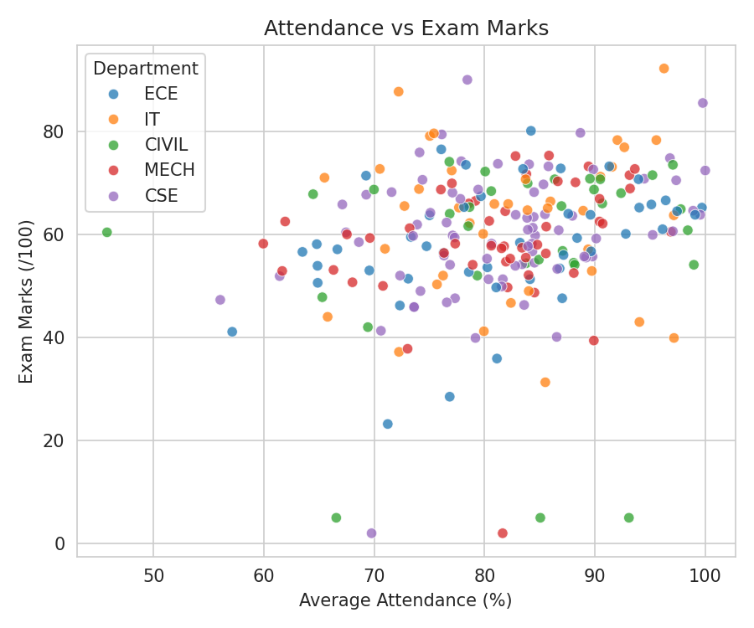
Figure 4: Attendance vs. Exam Marks (by Department)
As expected, Exam Marks and Internal Marks are the strongest drivers of overall Total Score, confirming the composite formula behaves sensibly. Attendance shows only a weak positive correlation with exam performance, and Assignment Marks show almost no relationship with exam outcomes - suggesting assignments may be scored on effort/completion rather than mastery, and that regular class attendance alone does not guarantee strong exam results without matching internal-assessment effort.

7. Outlier Detection
Outliers were identified using the Interquartile Range (IQR) method (values beyond Q1 - 1.5*IQR or Q3 + 1.5*IQR) applied separately to Exam Marks and Average Attendance.
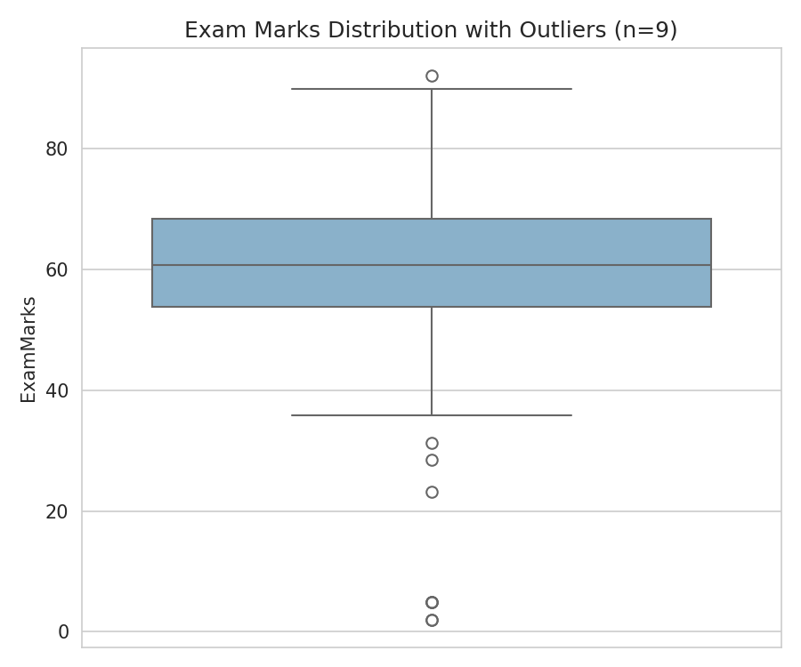
Figure 5: Exam Marks Boxplot (Outliers Highlighted)
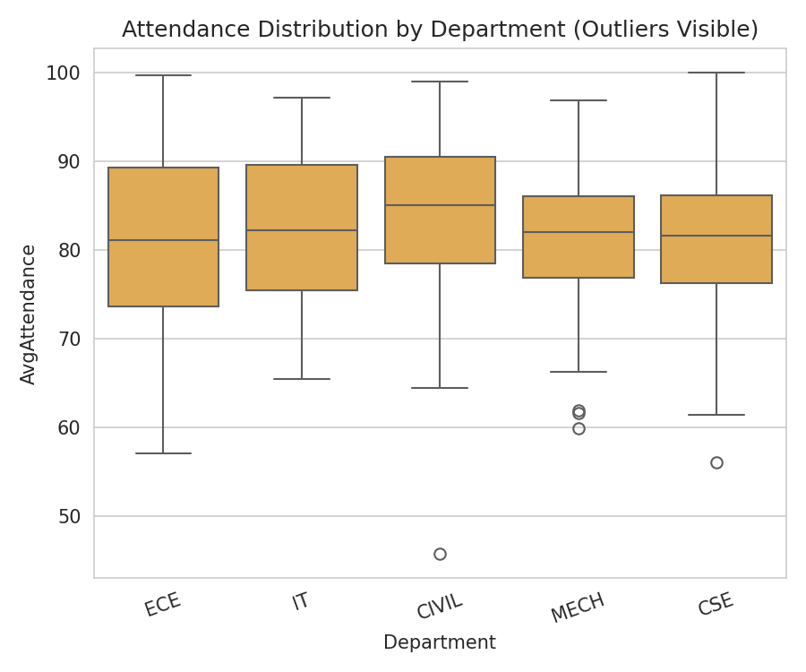
Figure 6: Attendance Distribution by Department
9 exam-mark outliers and 3 attendance outliers were detected. A sample of the flagged students is shown below:
StudentID | Department | Avg. Attendance (%) | Exam Marks | Total Score | Flag
STU1070 | CIVIL | 93.1 | 5.0 | 25.6 | Very low exam despite high attendance
STU1092 | CIVIL | 85.1 | 5.0 | 35.9 | Very low exam score
STU1120 | CIVIL | 66.6 | 5.0 | 36.0 | Very low exam score
STU1146 | MECH | 81.6 | 2.0 | 25.7 | Very low exam score
STU1201 | CSE | 69.8 | 2.0 | 25.8 | Very low exam score
STU1080 | IT | 96.3 | 92.2 | 88.8 | Exceptionally high achiever
STU1025 | CIVIL | 45.8 | 60.4 | 66.6 | Attendance outlier (low) but passing
STU1046 | ECE | 57.1 | 41.1 | 44.7 | Attendance outlier (low)
The pattern is important: several outliers show high attendance but near-zero exam marks, which typically signals exam-day absenteeism, medical emergencies, or severe exam anxiety rather than a lack of preparation - these cases warrant individual counselling review rather than generic academic remediation.

8. Time-Based Analysis
Monthly attendance (Jan-Jun) and internal-exam performance (Internal 1 to Internal 3) were tracked over time to detect trends.
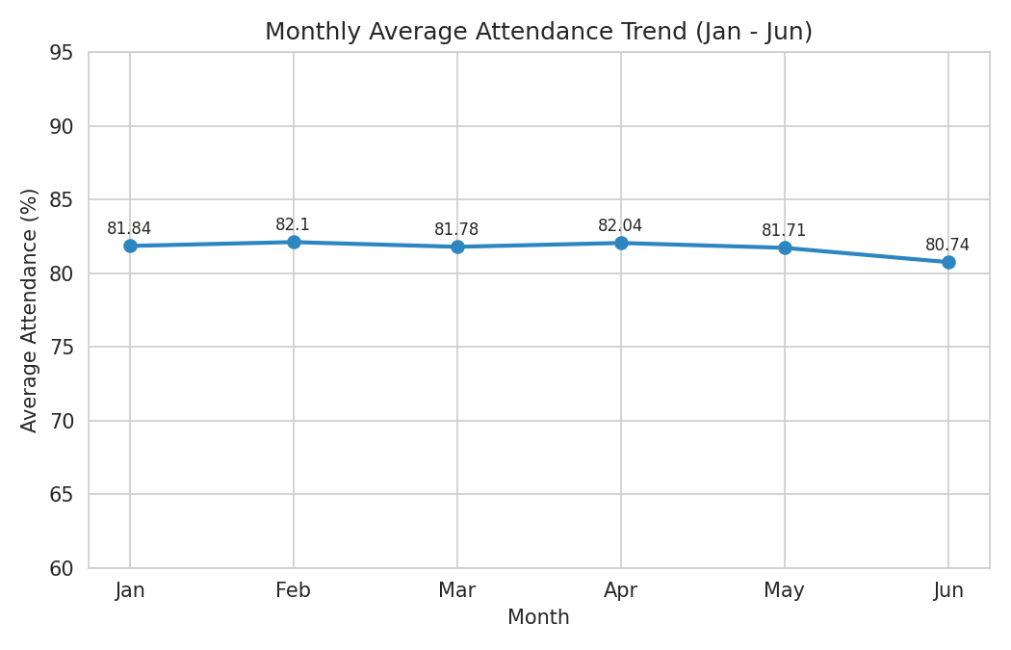
Figure 7: Monthly Average Attendance Trend
Month | Jan | Feb | Mar | Apr | May | Jun
Avg. Attendance (%) | 81.84 | 82.10 | 81.78 | 82.04 | 81.71 | 80.74
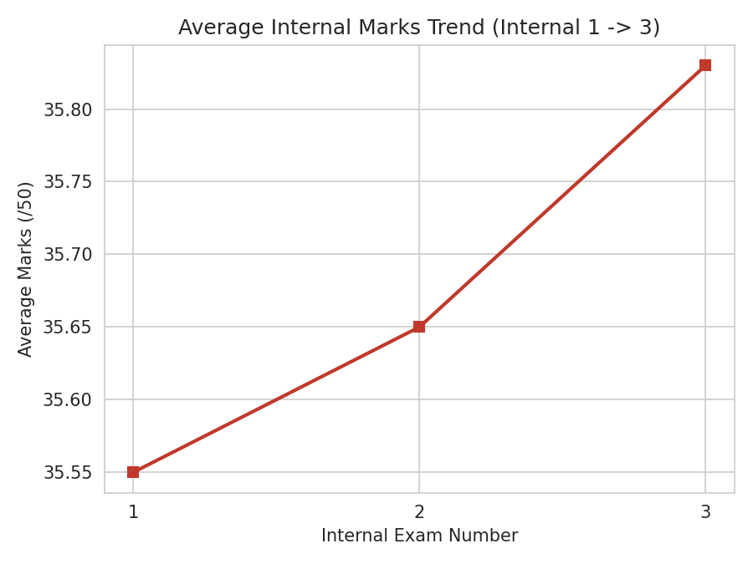
Figure 8: Average Internal Marks Trend
Internal Exam | Internal 1 | Internal 2 | Internal 3
Avg. Marks (/50) | 35.55 | 35.65 | 35.83
Attendance stays broadly stable through the semester but dips noticeably in June - consistent with typical end-of-semester fatigue, project deadlines, or exam-leave patterns. Internal marks show a mild but steady upward trend across the three internal assessments, indicating that continuous assessment slightly improves student preparedness as the semester progresses.

9. Visualization
In addition to the charts embedded in Sections 4-8 (department/semester bar charts, segmentation pie chart, correlation heatmap, scatter plot, boxplots and trend lines), the overall grade distribution across the cohort is shown below.
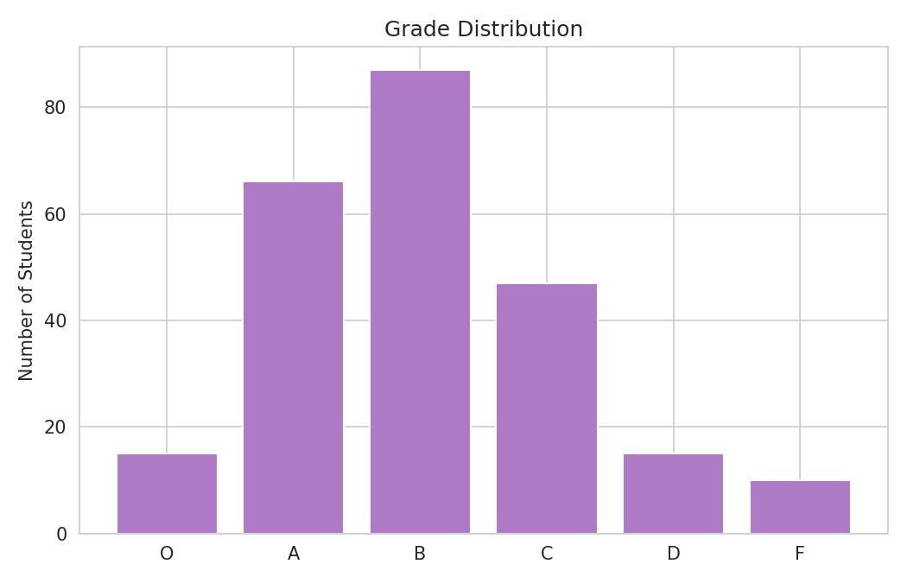
Figure 9: Overall Grade Distribution
Grade | O | A | B | C | D | F
Count | 15 | 66 | 87 | 47 | 15 | 10
Grades follow a roughly normal, slightly right-skewed distribution centred on B, with a manageable but non-trivial tail of D/F grades (25 students, ~10.4%) requiring academic support.

10. Key Findings, Conclusion & Recommendations

10.1 Key Findings
- Exam performance is the dominant driver of overall score (r = 0.93 with Total Score), followed by Internal Marks (r = 0.78); Assignment Marks have almost no correlation with exam outcomes (r = 0.04).
- The IT department leads in average total score (67.05), while ECE and MECH trail behind at ~63; Semester 5 is the weakest-performing cohort across the institution (avg. total score 60.76).
- About 30% of students (72 of 240) fall into the At-Risk performance band, with CSE contributing the largest absolute number of At-Risk students (22) due to its larger cohort size.
- Attendance alone is a weak predictor of exam success (r = 0.23) - several students with 90%+ attendance still scored under 10 marks in exams, pointing to exam-specific stress or emergencies rather than lack of engagement.
- Average attendance dips in June (80.74%) relative to the semester start, while internal-assessment performance trends mildly upward across Internal 1 to Internal 3, showing continuous assessment is working as intended even as attendance discipline weakens.

10.2 Recommendations
- Introduce mandatory academic counselling for the 72 At-Risk students, prioritising those with high attendance but very low exam marks, who may need psychological or exam-readiness support rather than remedial classes.
- Investigate Semester 5 specifically (curriculum load, faculty allocation, or scheduling clashes with placement drives) since it consistently underperforms other semesters.
- Redesign assignment evaluation rubrics to better correlate with exam-relevant skills, since current assignment scores show negligible predictive value for exam performance.
- Launch department-specific interventions: volume-scale peer-mentoring for CSE (largest At-Risk count) and an advanced/stretch track for MECH (zero High Performers).
- Deploy an attendance early-warning system for June/end-of-semester weeks, when attendance is most likely to fall, to prevent last-mile disengagement before final exams.

10.3 Conclusion
The integrated analysis of Student, Attendance, Internal Marks, Assignment and Examination data confirms that consistent internal-assessment performance, not attendance or assignment completion alone, is the strongest predictor of final academic outcomes. With nearly a third of students falling into the At-Risk band, targeted, data-driven interventions - especially around Semester 5 and the CSE/MECH departments - can meaningfully improve overall academic performance across the institution.

